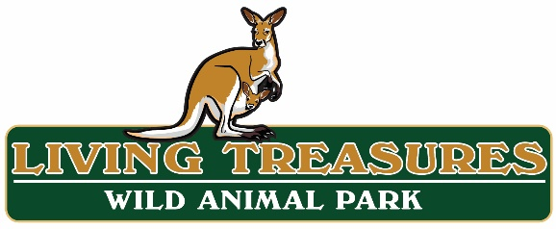
EMPLOYMENT APPLICATION

Date of Application: _____________
Please type or print legibly and complete all information
- Name: _________________________________________________________________________________________________
- Address: _______________________________________________________________________________________________
- Home Phone No. ________________________________________________________________________________________
- Cell Phone No. __________________________________________________________________________________________
- Email Address: __________________________________________________________________________________________
- Position(s) Applying for (circle one or multiple)
  - Animal Care
  - General Maintenance & Construction
  - Gift Shop and Park Admission Attendant
  - Advanced Management (Previous field experience required relating to management position applying for)
  - Pony, horse, and camel ride attendant
  - Keystone Safari Zipline & Adventure Park

- Job Interest (circle one or multiple)
  - Full Time Part Time Seasonal
- Available Start Date: _____________________________________________________________________________________
  - This park is open 7 days a week during our operating season, including holidays. Circle days available to work

    - Monday
    - Tuesday
    - Wednesday
    - Thursday
    - Friday
    - Saturday
    - Sunday

- During your first 30 (thirty) days of availability to work, please list all dates you are not available including holidays.
  - __________________________________________________________________________________________
- At any point in the first 90 (ninety) days of availability to work, will you be unavailable for more than 4 consecutive days? This includes traveling, family visiting, etc. ___ Yes ___ No If yes, please list: __________________________________
- Pay Rate Expected: $________
- If seasonal, what is the last day you are available to work? _______________________________________________________
- Hours a week you are interested in working? __________________________________________________________________
- Are you 18 years of age or older? ___ Yes ___No If no, list age: ______________
- Are you a US Citizen ___ Yes ___No
  - If not, do you have the legal right to remain permanently in the US? ___ Yes ___No
- Do you have a valid driver’s license? ___ Yes ___No
- Have you ever applied for a position at Living Treasures/Keystone Safari? ___ Yes ___No
  - If yes, when? ____________________________________________________________________________________
  - Did you have an interview? ___ Yes ___No
  - Were you hired? ___ Yes ___No
  - If you were hired by Living Treasures/Keystone Safari in the past:
    - List dates of employment ___________________________________________________________________
    - What was your position and duties ___________________________________________________________
    - Reason for leaving _________________________________________________________________________
- Have you ever been convicted of a violent crime or theft? ___ Yes ___No
  - If yes, give date and describe offense in detail:_________________________________________________________________________________________________________________________________________________________________________________________
- Please list any reasons (physical or not) that may keep you from performing the job(s) applied for:
__________________________________________________________________________________________________________________________________________________________________________________________________________________________
- Summarize any special training, skills, licenses and/or certificates that may assist you in performing the duties of the position for which you are applying:
__________________________________________________________________________________________________________________________________________________________________________________________________________________________________________________________________________________________________________________________________________

- Please explain why and how we would benefit by making you a part of the Living Treasures Animal Park staff (List any experience in the field, attributions, etc.) Use back of page if necessary.
__________________________________________________________________________________________________________________________________________________________________________________________________________________________
List your two most recent employers.
Company Name Telephone | Company Name Telephone
Start Date Last Day Worked | Start Date Last Day Worked
Job Title/Responsibilities | Job Title/Responsibilities
Supervisor’s Name Title | Supervisor’s Name Title
Reason for Leaving | Reason for Leaving
List 3 (three) references not related to you. List phone numbers and how long they’ve known you.
Name Phone Number How long have they known you?
Name Phone Number How long have they known you?
Name Phone Number How long have they known you?

Acknowledgement & Release (please read thoroughly before signing.)
I certify that answers given are true and complete to the best of my knowledge. I authorize investigation of all statements contained in this form as may be necessary in arriving at employment decision. I understand that this application is not and was not intended to be a contract of employment. In the event of employment, I understand that false or misleading information given in my application or interview may result in discharge. I understand also, that I am required to abide by all rules and regulations of Living Treasures Animal Park, and failure to do to may result in discharge.

__________________________________________________ ______________________________________________________
Signature Date

